AIML SESSION 09 ASSIGNMENT SUBMISSION

Name of Student : Vaibhav Vijay Kate
Domain/Subject : AIML (Artificial Intelligence & Machine Learning)
College : Government Polytechnic College Washim
Branch : Information Technology
Session : 09

Q1
Q1. Creating Dictionaries)
Write a program to create dictionaries using different methods:
a) An empty dictionary using two different ways.
b) A dictionary with string keys (name, city, course).
c) A dictionary with integer keys.
d) A mixed data type dictionary (string, int, float).
Print each dictionary and its type. Add comments explaining the syntax.

Program Code:
# a) Empty dictionary using two different ways
# Method 1: Using {}
d1 = {}
print("d1 =", d1)
print("Type:", type(d1))
# Method 2: Using dict()
d2 = dict()
print("d2 =", d2)
print("Type:", type(d2))
# b) Dictionary with string keys
d3 = {
"name": "Vaibhav",
"city": "Washim",
"course": "AI-ML"
}
print("\nd3 =", d3)
print("Type:", type(d3))
# c) Dictionary with integer keys
d4 = {
1: "India",
2: "China",
3: "America",
4: "Japan"
}
print("\nd4 =", d4)
print("Type:", type(d4))
# d) Mixed data type dictionary
d5 = {
"Brand": "TATA", # String
"Wheels": 6, # Integer
"Distance": 129.0 # Float
}
print("\nd5 =", d5)
print("Type:", type(d5))

Output Screenshot: 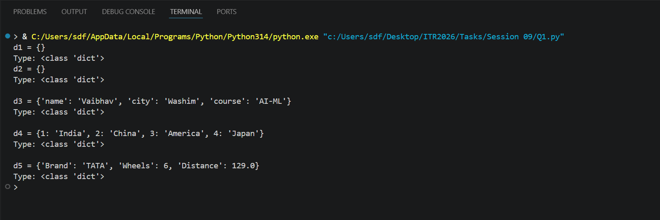

Q2
Q2. Accessing and Modifying Elements)
Create the dictionary:
student = {
"name": "YourName",
"age": 00,
"city": "YourCity",
"marks": 00
}
Print the value of "name" using square brackets.
Update the "marks" to 92.
Add a new key "grade" with value "A".
Print the updated dictionary.

Program Code:
# Q2. (Accessing and Modifying Elements)
# Create the dictionary
student = {
"name": "Vaibhav",
"marks": 85,
"city": "Washim"
}
# Print the value of "name" using square brackets
print("Name:", student["name"])
# Update the "marks" to 92
student["marks"] = 92
# Add a new key "grade" with value "A"
student["grade"] = "A"
# Print the updated dictionary
print("Updated Dictionary:", student)

Output Screenshot: 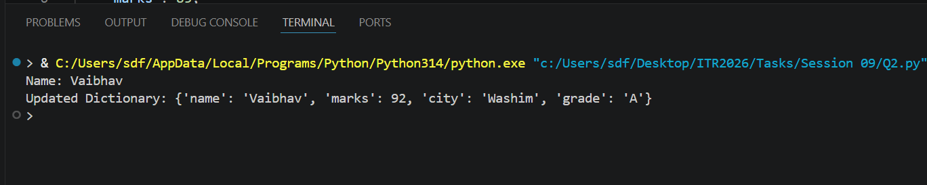

Q3
Q3. (get(), keys(), values(), items())
Create a dictionary:
person = {"name": "Priya", "age": 21, "profession": "Engineer"}
Demonstrate:
a) Using get() to access "age" and a non-existing key "salary" (with default value).
b) Print all keys using keys().
Session 09 (AIML) - Assignment Questions 1
c) Print all values using values().
d) Print all key-value pairs using items().

Program Code:
person= {"name": "Priya", "age": 21, "profession": "Engineer"}
# a) Using get() to access "age" and a non-existing key "salary"
print(person.get("age"))
print(person.get("salary", "Not Found"))
# b) Print all keys
print(person.keys())
# c) Print all values
print(person.values())
# d) Print all key-value pairs
print(person.items())

Output Screenshot: 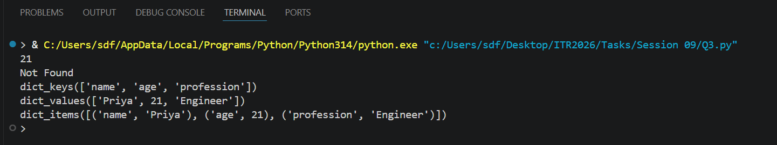

Q4
Q4. Nested Dictionary)
Create a nested dictionary to store information of two students:
Python
students = {
"s1": {"name": "Rahul", "age": 20, "marks": 88},
"s2": {"name": "Sneha", "age": 21, "marks": 95}
}
Print the details of the first student.
Print the marks of the second student.
Add a new subject "math" with marks 90 for the first student.

Program Code:
students= {
"s1": {"name": "Rahul", "age": 20, "marks": 88},
"s2": {"name": "Sneha", "age": 21, "marks": 95}
}
# Print the details of the first student
print("First Student Details:")
print(students["s1"])
# Print the marks of the second student
print("Second Student Marks:")
print(students["s2"]["marks"])
# Add a new subject "math" with marks 90 for the first student
students["s1"]["math"] = 90
# Print updated first student details
print("Updated First Student Details:")
print(students["s1"])

Output Screenshot: 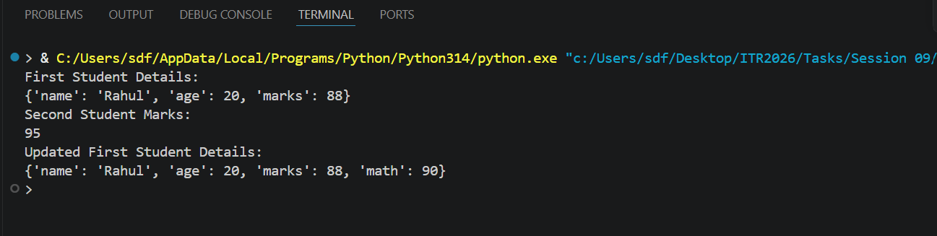

Q5
Q5. (update() and pop())
Create a dictionary: info = {"brand": "Samsung", "model": "A52", "price": 25000
Update it with new information: {"color": "Black", "price": 24000.
Remove the key "model" using pop() and print the removed value.
Print the final dictionary.

Program Code:
# Q5. (update() and pop())
# Create a dictionary: info = {"brand": "Samsung", "model": "A52", "price": 25000}
# Update it with new information: {"color": "Black", "price": 24000}.
# Remove the key "model" using pop() and print the removed value.
# Print the final dictionary.
# Q5. (update() and pop())
info = {
"brand": "Samsung",
"model": "A52",
"price": 25000
}
# Update dictionary
info.update({
"color": "Black",
"price": 24000
})
# Remove "model" and store removed value
rm_value = info.pop("model")
# Print removed value
print("Removed Value:", rm_value)
# Print final dictionary
print("Final Dictionary:", info)

Output Screenshot: 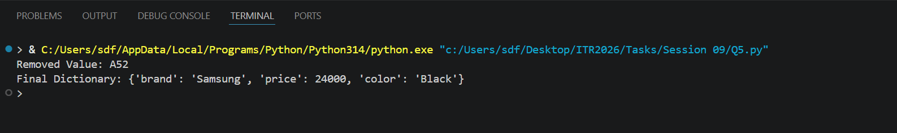

Q6
Q6. (popitem() and clear())
Create a dictionary with at least 5 key-value pairs.
Use popitem() twice and print the removed items each time.
Clear the entire dictionary using clear().
Print the final result.
Add comments explaining the difference between pop() and popitem().

Program Code:
# Create a dictionary with 5 key-value pairs
student = {
"name": "Rahul",
"age": 20,
"marks": 88,
"grade": "A",
"city": "Mumbai"
}
# Remove and print the last inserted item
removed_item1 = student.popitem()
print("First removed item:", removed_item1)
# Remove and print the next last inserted item
removed_item2 = student.popitem()
print("Second removed item:", removed_item2)
# Print dictionary after popitem()
print("Dictionary after popitem():", student)
# Clear the entire dictionary
student.clear()
# Print final result
print("Final Dictionary:", student)
# Difference between pop() and popitem():
# pop(key) -> Removes a specific key and returns its value.
# popitem() -> Removes the last inserted key-value pair

Output Screenshot: 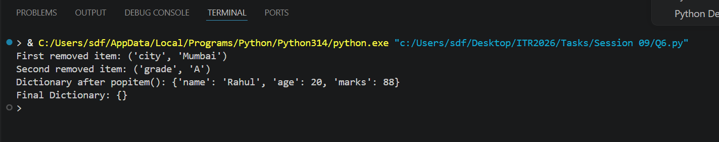

Q7
Q7. (copy() and setdefault())
Create a dictionary: d = {"a": 1, "b": 2
Make a copy of it.
Session 09 (AIML) - Assignment Questions 2
Use setdefault() to add key "c" with value 3 (if it doesn't exist).
Use setdefault() again for an existing key "a".
Print the original and copied dictionaries.

Program Code:
# Q7. (copy() and setdefault())
# Create a dictionary
d = {"a": 1, "b": 2}
# Make a copy of the dictionary
d_copy = d.copy()
# Add key "c" with value 3 if it doesn't exist
d.setdefault("c", 3)
# Use setdefault() on existing key "a"
d.setdefault("a", 100)
# Print original and copied dictionaries
print("Original Dictionary:", d)
print("Copied Dictionary:", d_copy)

Output Screenshot: 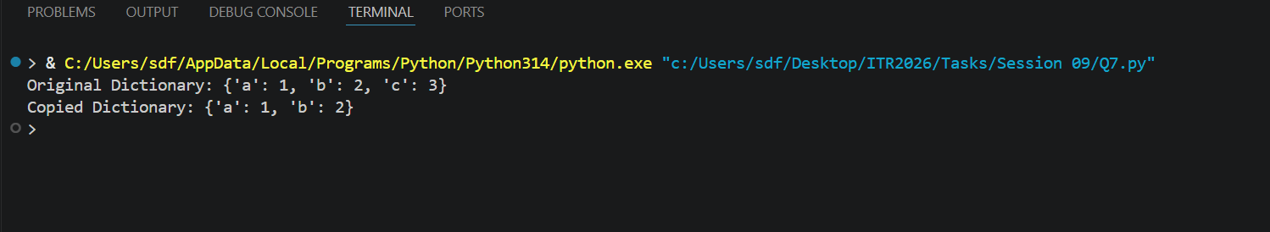

Q8
Q8. (fromkeys() and Membership)
Write a program that:
Uses dict.fromkeys() to create a dictionary with keys ["name", "age", "city"]
and default value None.
Takes user input to fill these keys.
Checks if a given key exists using in operator.

Program Code:
# Q8. (fromkeys() and Membership)
# Create a dictionary with default value None
keys = ["name", "age", "city"]
person = dict.fromkeys(keys, None)
# Take user input
person["name"] = input("Enter your name: ")
person["age"] = input("Enter your age: ")
person["city"] = input("Enter your city: ")
# Print dictionary
print("\nDictionary:", person)
# Check if a key exists
key = input("\nEnter a key to check: ")
if key in person:
print("Key exists in the dictionary.")
else:
print("Key does not exist in the Dictionary.")

Output Screenshot: 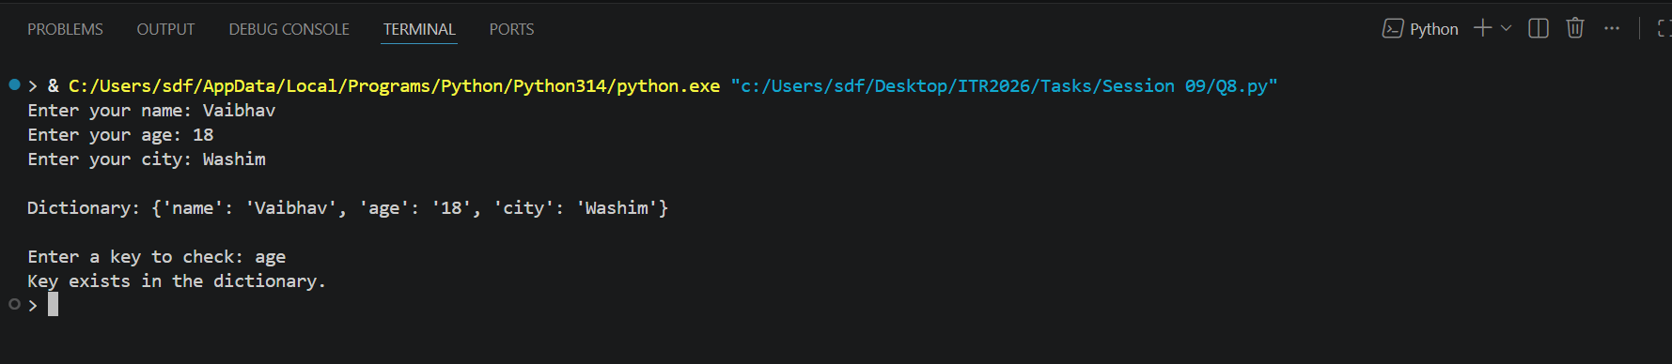

Q9
Q9. Practical Application)
Write a program to store and manage contact information using a dictionary:
Take name, phone number, and email as input.
Store them in a dictionary with name as key.
Allow the user to search a contact by name using get().
Print all contacts using items().

Program Code:
# Contact Management System
contacts = {}
# Take input from user
name = input("Enter Name: ")
phone = input("Enter Phone Number: ")
email = input("Enter Email: ")
# Store contact information
contacts[name] = {
"phone": phone,
"email": email
}
# Search contact using get()
search_name = input("\nEnter name to search: ")
contact = contacts.get(search_name)
if contact:
print("\nContact Found:")
print("Phone:", contact["phone"])
print("Email:", contact["email"])
else:
print("Contact not found.")
# Print all contacts using items()
print("\nAll Contacts:")
for name, details in contacts.items():
print("Name:", name)
print("Phone:", details["phone"])
print("Email:", details["email"])
print()

Output Screenshot: 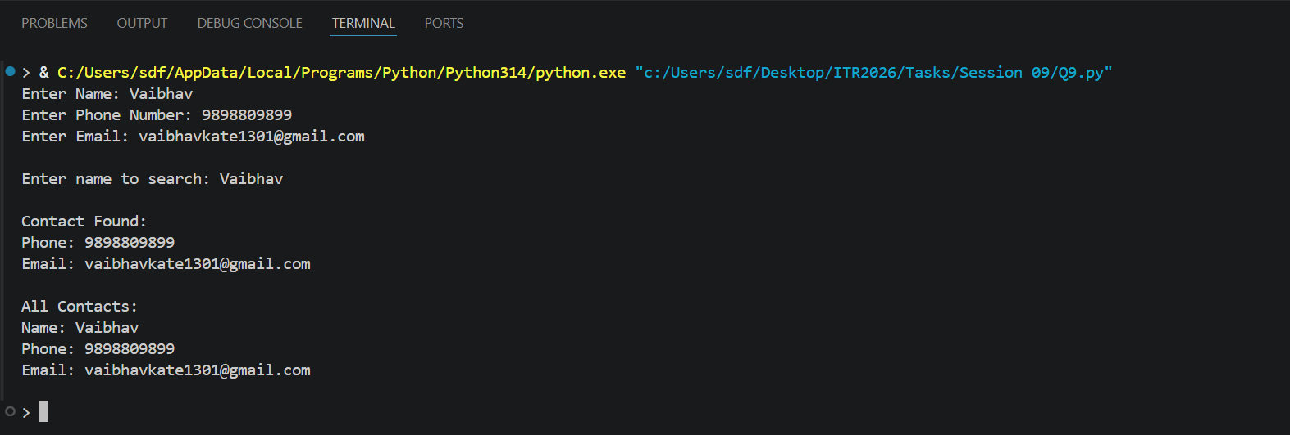

Q10
Q10. Mini Project - Combined Concepts)
Create a Student Management System using a dictionary:
Repeatedly ask the user to enter student details (roll number as key, and a
nested dictionary containing name, age, and marks).
Use a while loop with a menu:
Add new student
Update marks of a student
Search student by roll number
Display all students
Remove a student
Exit
Session 09 (AIML) - Assignment Questions 3
Use appropriate dictionary methods (get(), update(), pop(), etc.). Add meaningful
comments.
Session 09 (AIML) - Assignment Questions 4

Program Code:
# Student Management System
students = {}
while True:
print("\n===== Student Management System =====")
print("1. Add New Student")
print("2. Update Marks")
print("3. Search Student")
print("4. Display All Students")
print("5. Remove Student")
print("6. Exit")
choice = input("Enter your choice (1-6): ")
# 1. Add New Student
if choice == "1":
roll = input("Enter Roll Number: ")
name = input("Enter Name: ")
age = int(input("Enter Age: "))
marks = float(input("Enter Marks: "))
students[roll] = {
"name": name,
"age": age,
"marks": marks
}
print("Student added successfully!")
# 2. Update Marks
elif choice == "2":
roll = input("Enter Roll Number: ")
if roll in students:
new_marks = float(input("Enter New Marks: "))
students[roll]["marks"] = new_marks
print("Marks updated successfully!")
else:
print("Student not found!")
# 3. Search Student
elif choice == "3":
roll = input("Enter Roll Number: ")
student = students.get(roll)
if student:
print("\nStudent Details:")
print("Name:", student["name"])
print("Age:", student["age"])
print("Marks:", student["marks"])
else:
print("Student not found!")
# 4. Display All Students
elif choice == "4":
if students:
print("\nAll Students:")
for roll, details in students.items():
print(f"\nRoll No: {roll}")
print("Name:", details["name"])
print("Age:", details["age"])
print("Marks:", details["marks"])
else:
print("No students available!")
# 5. Remove Student
elif choice == "5":
roll = input("Enter Roll Number: ")
if roll in students:
removed_student = students.pop(roll)
print("Removed Student:", removed_student)
else:
print("Student not found!")
# 6. Exit
elif choice == "6":
print("Exiting Student Management System...")
break
else:
print("Invalid choice! Please enter a number between 1 and 6.")

Output Screenshot: 